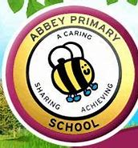
Abbey Primary School Health and Wellbeing:
You looking after you is important
Mindfulness is all about living in the moment and appreciating everything that surrounds you. Sometimes, that is very hard to do! To take some mindfulness time means you can focus on 4 things:
- Your emotions
- Your judgments
- Your thoughts
- Your joy
By taking time out to still your mind, you can really think about how you actually feel and process it.
Here are some more breathing techniques for you to try. I hope you enjoy having a go!
SENSE COUNTDOWN
1. Sit or stand straight and still. Close your eyes or look downward.
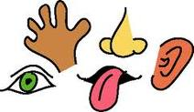
2. Take three deep breaths in and out.
3. Open your eyes.
- Notice five things you can see.
- Notice four things you can touch.
- Notice three things you can hear.
- Notice two things you can smell.
- Notice one thing you can taste.

MINDFUL EXPLORERS
1. Head outside and imagine that you are an explorer in a land where humans have never been before.
2. Remain quiet, calm your thoughts and move slowly while you are exploring.
3. Turn your sense of sight, touch and sound onto high.
4. Search for a natural object or small creatures to examine.
Guiding questions- What does it look like? - What colour is it? - What does it smell like? - Can you touch it safely? - What does it feel like? - How does it move? - What shapes and lines can you see in it?
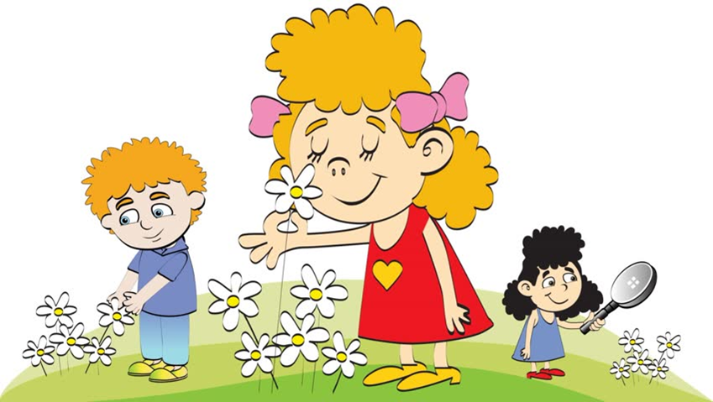
MINDFUL STEPS
1. Head outside and find a small area where you can walk in a line for five steps, then turn and walk back again, without interruption. You may like to take off your shoes and socks.
2. Stand still and straight. Take three slow, deep breaths in and out.
3. Take five steps in one direction, walking slowly and noticing how your body moves with each step.
4. Listen to the sounds around you and the sound your feet make on the ground. Try not to change the way you walk, but instead just notice how your body naturally moves.
Guiding Questions - What does the ground feel like under your feet? - When you take a step, which part of your foot touches the ground first? - Does your body feel heavy or light today? - Are you slouching when you walk or is your back up straight? (Ideas can be found @ www.teachstarter.com)

